

|  |  |  |  |  |  |
| --- | --- | --- | --- | --- | --- |
| Programme | : | **B.Tech (CSE)** | Semester | : | **Fall 2016** |
| Course | : | **Internet and Web Programming (Embedded Lab)** | Code | : | **CSE3002** |
| Faculty | : | **Prof. Rajiv Vincent**  **Prof. M.Premalatha** | Slot | : | **L7+L8** |

**Ex. No: 6**

**Date: 30/08/16**

**Virtual lab – HTML CSS and Javascript**

Assume that you are registering courses in your FFCS login. Display a catalogue page which displays the available courses and its credits for a semester with checkboxes for each course for selection. Slot for each course should be given using dropdown (Both morning and afternoon). Each slot should be allocated with the faculty name as below:

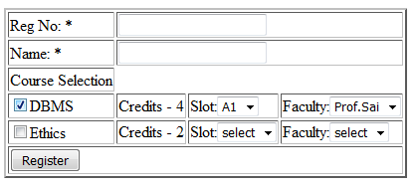

Form Design Constraint:

* If morning slots are selected, faculties who are handling morning slots of that particular course alone should be displayed in the faculty list drop down button and vice versa.
* A faculty cannot be allotted with more than two courses and a course should be allotted with 2 faculties(1 for morning and 1 for afternoon batch)
* If a subject is checked, dropdown buttons for slots and faculty fields are mandatory.
* If a subject is not selected, dropdown buttons for slots and faculty fields should not be selected.

Form Design with CSS

* The form created should be done with tables.
* Apply CSS to table and form representations of your choice.

Perform the following using HTML Javascript:

1. Check the courses you want to register and register them by clicking a submit button.
2. The total number of credits for the selected courses should be greater than 20 and less than or equal to 27.
3. Minimum 6 Courses should be selected including lab only courses
4. If so, display all the selected course details (Course Name, slot and faculty details of each course ) and the total number of credits registered, in a tabular format inside the webpage